Meratun Junnut Anee

Id:1620527043

EEE499.8, Summer2020

Submitted to:

**Mohammad Ashrafuzzaman Khan**

**How we are different to others:**

* + Our Drone can fly from a selected area and can get back to the same place.
  + No need for manual help for this operation.
  + Detecting pollutants within short time.
  + Give preliminary streaming results.
  + Can take real time pictures and videos and will store it in a memory.
  + Sensors will give statistical DATA.
  + Will check air transparency.

**Related works:**

1. **Air Quality Monitoring for Sustainable Systems via Drone Based Technology***, IEEE, 2016, Author: Josefa Wivou, Lanka Udawatta, Ali Alshehhi, Ebrahim Alzaabi, Ahmed Albeloshi and Saeed Alfalasi*
2. **Development and Validation of a UAV Based System for Air Pollution Measurements*,*** *Publisher: MDPI,* *21 December, 2016**Author: Tommaso Francesco Villa (1), Farhad Salimi (2), Kye Morton (3), Lidia Morawska (1)* and Felipe Gonzalez (3)*
3. **Using UAV-Based Systems to Monitor Air Pollution in Areas with Poor Accessibility,** *Publisher: Hindawi, 7 August, 2017, Author: Oscar Alvear(1,2), Nicola Roberto Zema(3), Enrico Natalizio(3) and Carlos T. Calafate(1)*

**Reviews on related works:**

1. **Air Quality Monitoring for Sustainable Systems via Drone Based Technology**

This project mainly did their work on a 3D space. They collected the sampling data for a given location and then analyzed the situation based on the air pollutants concentration and their patterns. They monitored it using a drone with the system installed. They stored the data on a cloud storage and kept record of it.

Drones have become a very familiar and fascinating technology that can be employed to collect data from an outdoor environment which is difficult for humans. So, in this case to measure pollutant gases and other particles drone technology is a blessing.

Their system includes with:

* Drone and its remote control with a camera and display screen.
* Sensors and microcontrollers
* Real time reading and data storage in cloud
* Real time display on mobile device
* Monitored and viewed from anywhere
* Stored data is analyzed displayed on various monitors.

In this system there are different sensor technologies used for detecting various gases like O3, So2, Co2, CO, VOCs. Recent sensor technology is able to detect the level of these gases and find out the reasons. Their moto is to detect all kinds of pollutant gases and other elements emitted by human activities and other natural sources.

They used Arduino microcontrollers for data processing. Calibration of the sensors were also needed. All the sensors were connected to analog pins.

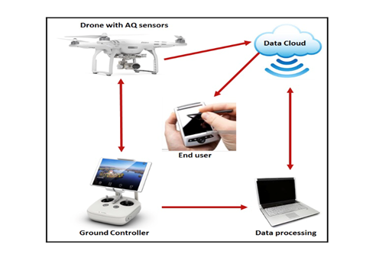

Fig: 01

They used 3 MQ type sensors for monitoring CO, Co2, CH4.

**Advantage:**

* Easy to built
* Maintenance cost minimum
* Easy to use
* Not expensive

**Disadvantage:**

* Sensitive System
* Connection and hardware system needs to be checked everyday.

Their system setup is currently experimented in Emirate of Ras Al Khaimah and could be used nationally and internationally. Sensors real time reading is processed through the arduino UNO microcontrollers and then stored on Blynk server. Then mobile app can display and base stations with GPS.

They used 3 axis stabilized camera and long range line view and 4k video recording option capabilities.

1. **Development and Validation of a UAV Based System for Air Pollution Measurements.**

The purpose of this project is to establish the best mounting point for 4types of gas sensor and a particle number concentration (PNC) monitor, onboard hexacopter. They tasted two different things:

* Evaluate the air flow behavior of hexacopter, it’s directional effect, airspeed, 3-axis to helicopter to determine the location.
* Evaluate the gas sensors for Co2, CO, NO, No2 and PNC monitor.

They examined that they got the best results with the airspeed behavior map produced by test1, the best mounting point. Test 2 resulted that the propellers cause a dispersion effect shown by decreasing of gas and PN concentration.

They also used a linear regression model to estimate the sensor position relative to the UAV center, where the pollutants concentration is higher and where the propellers switch on.

The UAV pilot, UAV GSO( ground station operator ) could connect with UAV wirelessly, using a radio controller transmitter or a computer.

|  |  |
| --- | --- |
| UAV Components | UAV Ground Components |
| Gas sensors | RC transmitter |
| Arduino | Ground Station |
| Battery | Telemetry link |
| DISC mini |  |
| RC receiver |  |
| S800Frame |  |

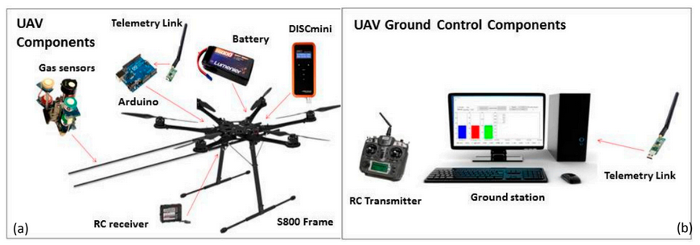

Fig: 02

They used a radio modem to transmit real data including information . They did their research from Australian research centre of aerospace automation indoor flying lab.

In test – 2, they went the 3 types of questions:

* How does the status of propellers (on/off) affect the measured gas and particle concentration?
* How does the position of the sensor(below/above/inside) affect the concentration?
* How does the distance from the UAV center affects the measured gas and particle concentration?

Advantage:

* Usable nationally and internally.
* Reliable project

Disadvantage:

* Long process
* Complex project
* Costly

1. **Using UAV-Based Systems to Monitor Air Pollution in Areas with Poor Accessibility**

This paper mainly offers the benefits and accessibility of the use of UAVs equipped sensors to perform how to monitor air pollution. This paper is proposed with pollution driven UAV control algorithms. This system can perform automatically monitoring of specific area. Using this system firstly we can make a map of where pollution occurs, what are the pollutants and where the concentration of the pollutants is higher. It works faster and has a higher accuracy.

From this paper I received the message why we need to monitor the air at urban areas and cities as well. Why we need to be more careful on it. They had proposed crowdsensing solutions in monitoring pollution in urban areas.

This system has the safety and security concern where it is dangerous to access by human operators. They also consider their paper as commercial and off h Th e shelf devices and sensors.

They also showed **chemotaxi** based approach for UAV path control which achieves faster and more accurate estimation of the location of the most polluted area with respect to classical area search approaches. I have learned about UAV based sensing, about UAV mobility models and also about UAV control protocols.

How a UAV control system works, I have got the idea. Also learned about UAV configuration system. They compared their algorithms against the Billiard and Spiral mobility model with simulation.

**Advantage:**

* High spacial and temporal resolution
* Low cost of operation in environmental monitoring
* UAV taken images are alternative of high resolution
* When it flies at low altitude and speeds offer new opportunities in terms of ecological phenomena measurements.

Fig: Proposed Model

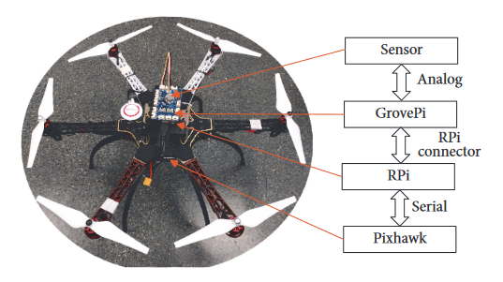

Fig: 03

From the flow chart:

To implement a UAV controlled drone, we need to focus on two aspects:

* Hardware

Here in this project they have designed a scheme where it dynamically drives UAV by connecting a UAV control module to a Raspberry Pi, using a Grove Raspberry Hat (Groove Pi) which allows connecting different sensors easily.

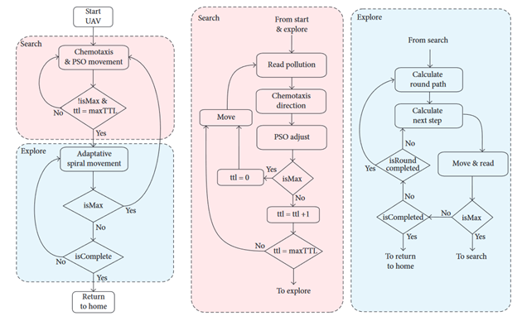

**Existing Solution:**

1. **Amel (UAV)**

It is an Algerian design of drone. Its design and manufacture is Star Aviation. It took its first flight at 2013. Algerian Air force is the primary user of this drone. From 2013 to present it gives it services.

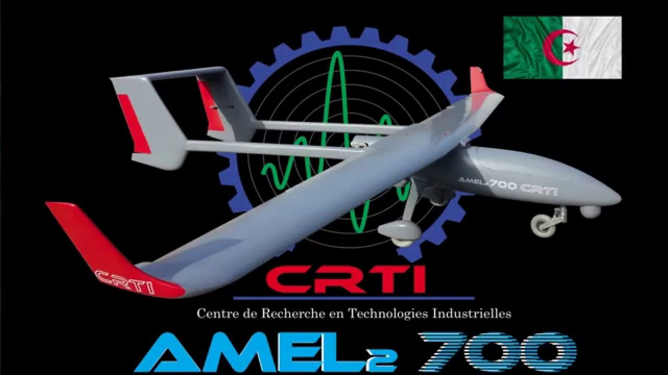

**Fig:4 Amel(UAV).**

1. **RedEdge-MX Dual Camera Imaging System**

This system has10-band multispectral solution incorporates the RedEdge-MX sensor and the new RedEdge-MX Blue, which features a new group of five filters including a coastal blue band and two new red edge bands. This is mainly designed to ensure easy data capture for research and drone/satellite comparisons, including applications such as shallow-water environmental monitoring and detailed chlorophyll efficiency analysis. To do comparison between satellite and drone data for efficient trend modelling, The Dual Camera Imaging System is the first MicaSense product to capture the Landsat 8 and Sentinel satellite bands, allowing for direct data. The complete package includes an integrated quick mounting bracket and wiring harness for swift, easy attachment to DJI drones.

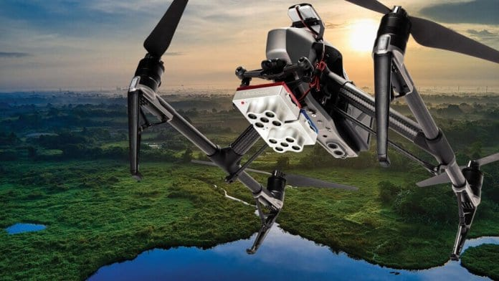

**Fig:5 RedEdge-MX Dual Camera Imaging System Drone.**

1. **Weather Sensors Aid Drone-Based Atmospheric Studies**

This project showed how UAV (unmanned aerial vehicle) manufacturers and researchers have used the company’s ultrasonic weather sensors to aid in drone-based atmospheric research and meteorological studies. Anemoment’s [TriSonica Mini Wind & Weather Sensor](https://anemoment.com/features/#trisonica-mini) is the world’s smallest and lightest 3D ultrasonic anemometer, providing high accuracy wind speed, direction, temperature, humidity, pressure, tilt, and compass data. Different companies selected this system for atmospheric research and meteorological studies.

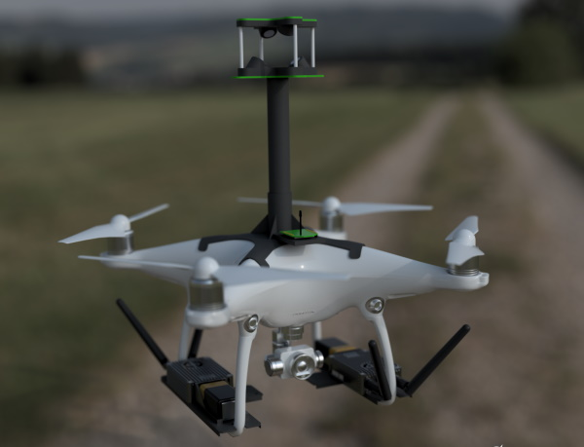

**Fig:6** Drone-based atmospheric research and meteorological studies.

1. **Drone-Based Electroluminescence Imaging of Solar Panels with SWIR Cameras**

[Raptor Photonics](https://www.raptorphotonics.com/) a famous company, has launched a drone explaining how its SWIR (short-wave infrared) cameras can be used in drone-based electroluminescence (EL) imaging of photovoltaic (PV) solar panels. To do high accuracy detection of defects and anything faults such as: broken cells, interconnections, cracks this system is perfect.

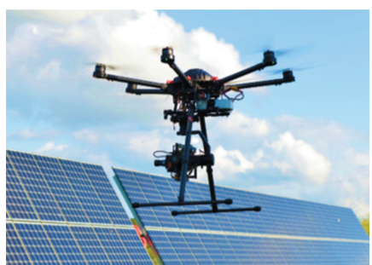

Fig: 7 Drone with Raptor 640 SWIR camera.

**References:**

1. [**https://www.unmannedsystemstechnology.com/wp-content/uploads/2019/10/MicaSense-DualCam-Multispectral-Drone-Imaging-Solution.jpg**](https://www.unmannedsystemstechnology.com/wp-content/uploads/2019/10/MicaSense-DualCam-Multispectral-Drone-Imaging-Solution.jpg)
2. [**https://www.unmannedsystemstechnology.com/wp-content/uploads/2020/01/TEN-TECH-LLC-Hurac%C3%A1n-Multi-Purpose-Aerial-Drone.jpg**](https://www.unmannedsystemstechnology.com/wp-content/uploads/2020/01/TEN-TECH-LLC-Hurac%C3%A1n-Multi-Purpose-Aerial-Drone.jpg)
3. [**https://i.ytimg.com/vi/SWjII7mxaZg/maxresdefault.jpg**](https://i.ytimg.com/vi/SWjII7mxaZg/maxresdefault.jpg)